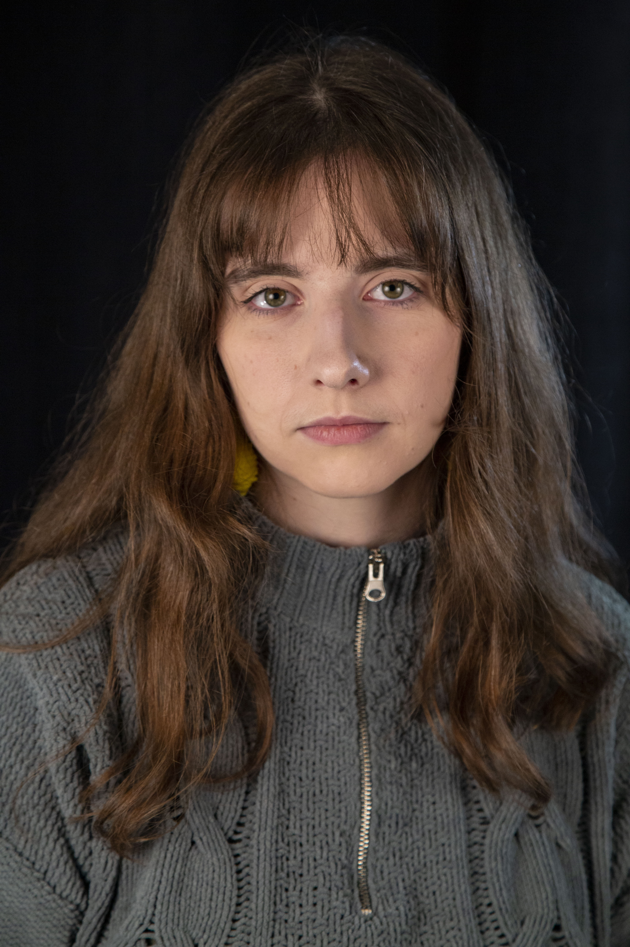

Abby Duggan
(302) 463-1029 Brown Eyes
abigailduggan19@gmail.com Brown Hair
Non Union 5’8”
Soprano

Theatre
Glory/Rhonda Almost, Maine Towson University
#00 (staged reading) The Wolves Towson University

Training
BFA in Acting Towson University
Voice (2 years) Towson University
Delaware Governor’s School for Excellence- Acting Elizabeth Heflin/University of Delaware

Special Skills
Juggling (beginner), soprano ukulele (intermediate), baritone ukulele (intermediate)

